FOUR BIT RIPPLE CARRY ADDER
LAB # 02


Spring 2025
CSE-308L
Digital System Design Lab

Submitted by: Naveed Ahmad
Registration No.: 22PWCSE2165
Class Section: B

Student Signature: ______________

Submitted to:
Engr. Shah Zada Fahim Jan
05 March 2025

Department of Computer Systems Engineering
University of Engineering and Technology, Peshawar

FOUR BIT RIPPLE CARRY ADDER
OBJECTIVES:
- Learn top down and bottom-up design methodologies
- Data flow level modeling
- Gate level modeling
Lab Tasks:
Implement a 4-bit ripple carry adder using:
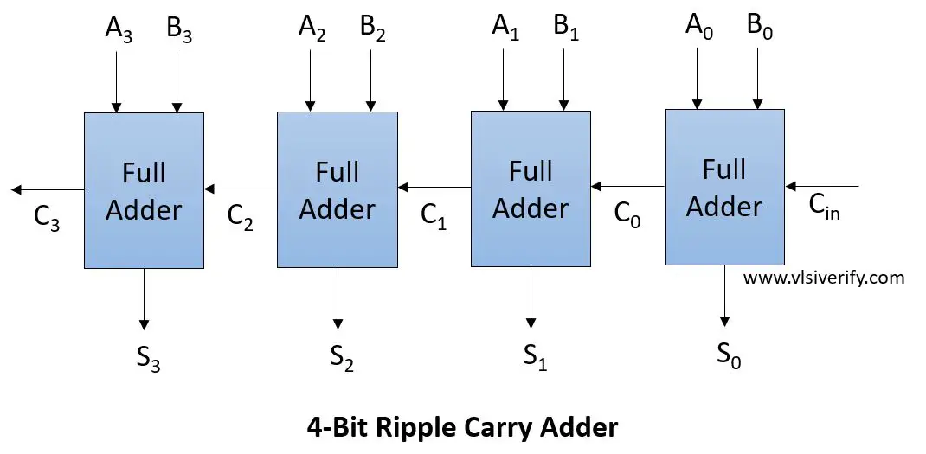

Task 1: Gate-level modeling?
Code
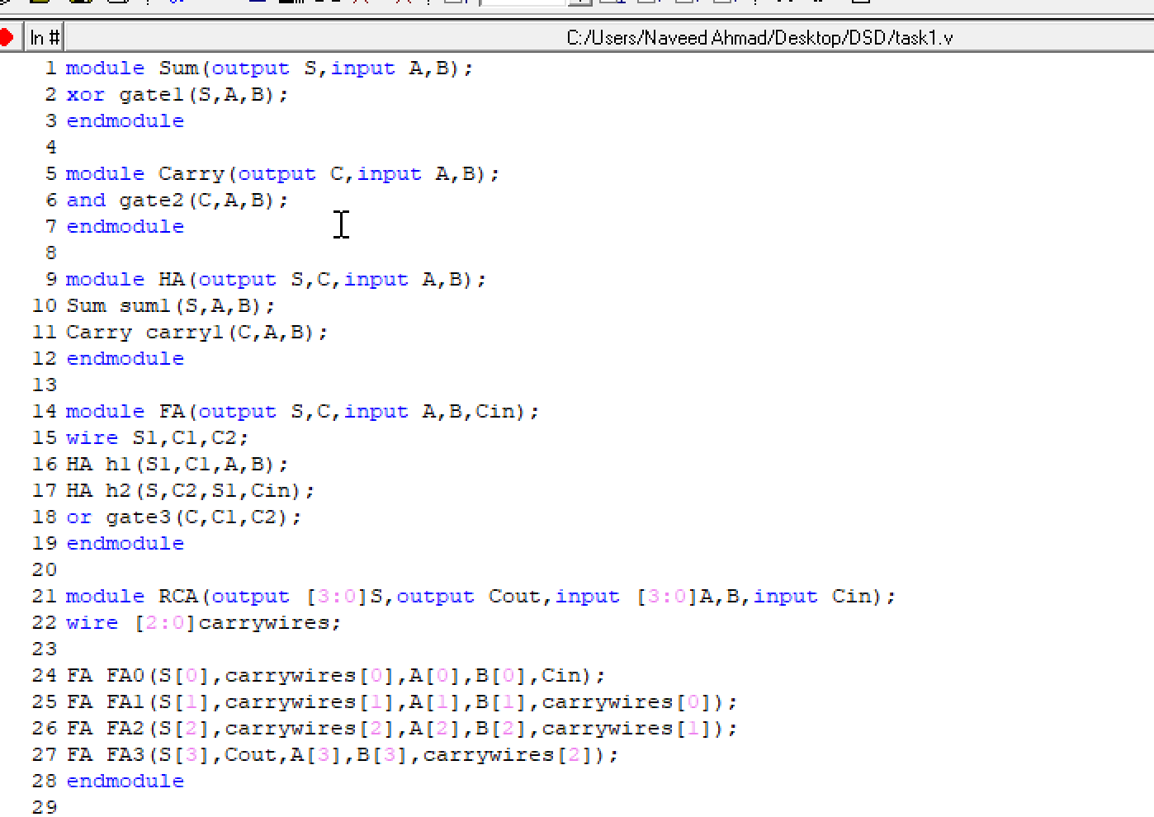

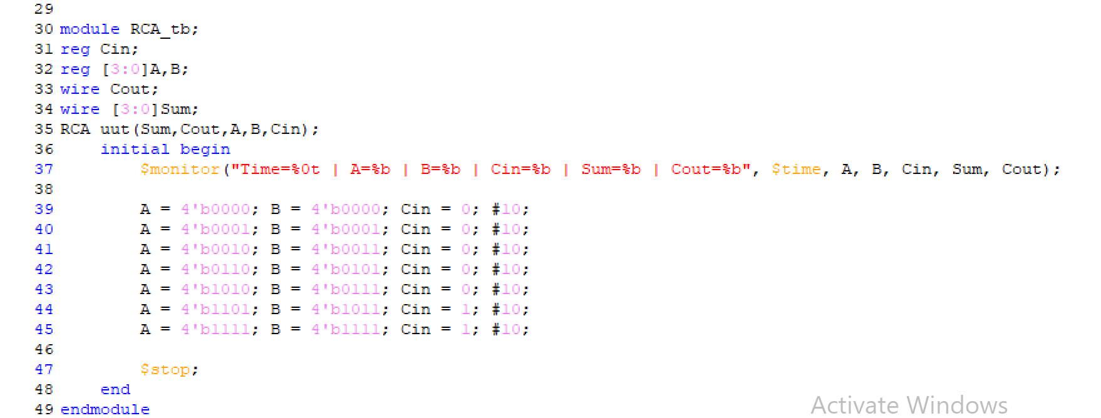
Truth table:
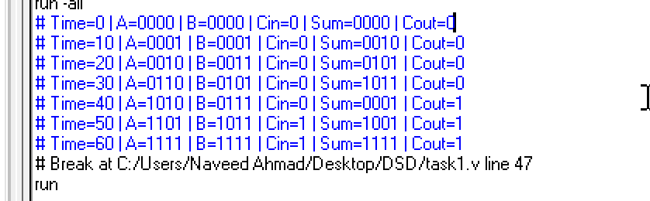
Output wave:
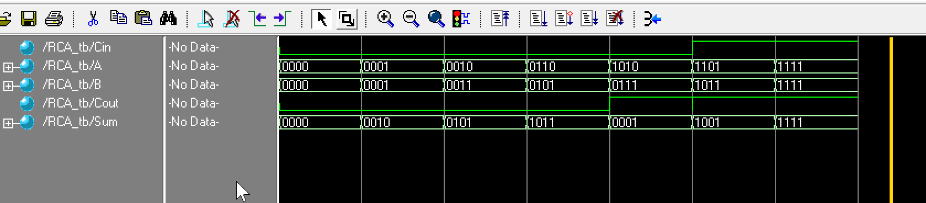

Task 2: Data-flow level modeling?
Code: 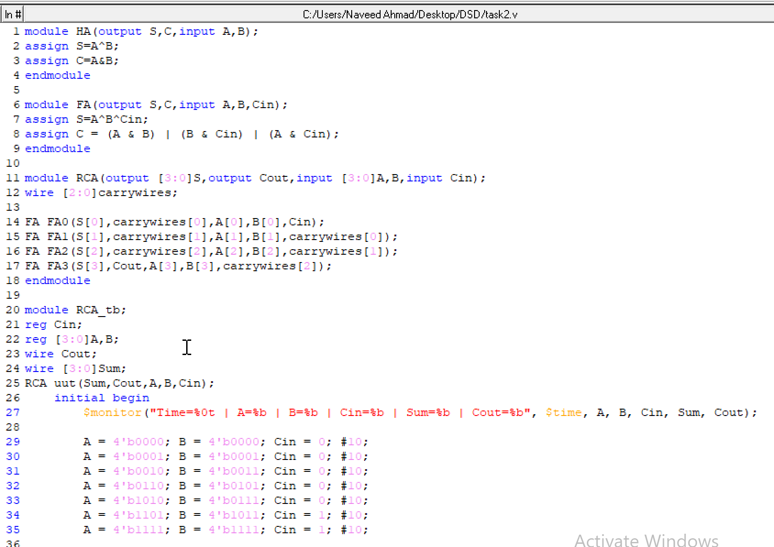

Truth table:
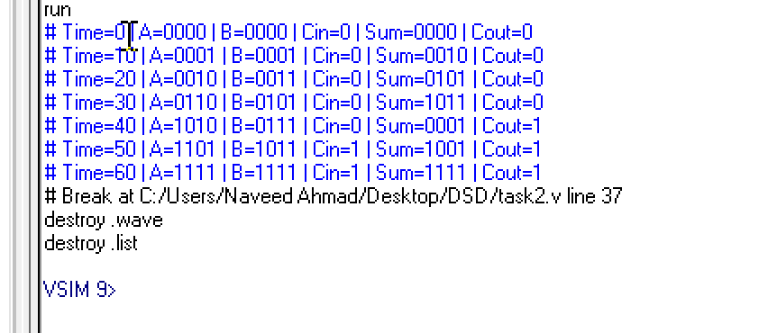

Wave:
